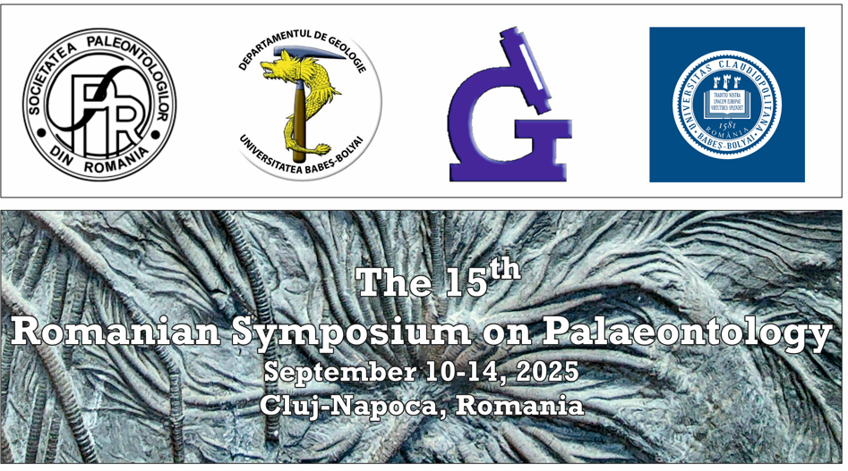

REGISTRATION FORM
(to be sent back to one of these e-mails: george.ples@ubbcluj.ro; cristian.micrcescu@ubbcluj.ro; carmen.chira@ubbcluj.ro before 1 of June, 2025)

Surname:
Family name:
Title:
Affiliation:
Address:
E-mail/phone:

Choose type (participant or accompanying person):
Full RSP member
Full non-RSP member
Student
Accompanying member

I will present a communication (choose type):
Oral
Poster

Title and Authors of communication:

I will participate to the following field-trip(s)

Pre-symposium field-trip (10 September) - MESOZOIC DEPOSITS FROM THE SOUTHERN APUSENI MOUNTAINS (BURU-CHEILE TURZII AREA

Yes No

Post-symposium field-trip (13-14 September) - UPPER CRETACEOUS, PALEOGENE AND MIOCENE DEPOSITS FROM MARAMURES AREA

Yes No

Symposium Dinner
Yes No

Dietary Requirements / Special needs
...........................................................

Important. When you send back the registration form please attach to the e-mail the following documents:

1. Payment confirmation of the registration fee
2. Payment confirmation of the symposium dinner fee (if selected)
3. Payment confirmation of fieldtrip(s) (if selected)

